# User manual, including quality of Written Communication

Contents

User manual, including quality of Written Communication 1

i. Introduction and installation instructions 2

ii. Detailed description of the use of the full system 2

Client usage screens 2

Admin usage screens 8

iii. Samples of error messages and error recovery procedures 16

## Introduction and installation instructions

This is a user manual for the newly designed ski Rossendale booking system section of the website. This is an integrated part of the site as a whole and will begin use on 1st August 2014. In this document is a detailed manual of how to use each input page the staff will be using. This system is designed for anybody after reading this manual to be able to fully use the system in a professional and effective manor; furthermore, there are also clear instructions on pages the user will use to work the system as a user.

## Detailed description of the use of the full system

There are a total of 19 data entry screens:

* 12 for admin use only.
* 7 for client use.

### Client usage screens

Inputcustomer.asp- this is the first page the user will visit on entrance to the site, where they can register their details in order to log on, the details will be sent and stored in the database, and they will then be redirected to the log on page.

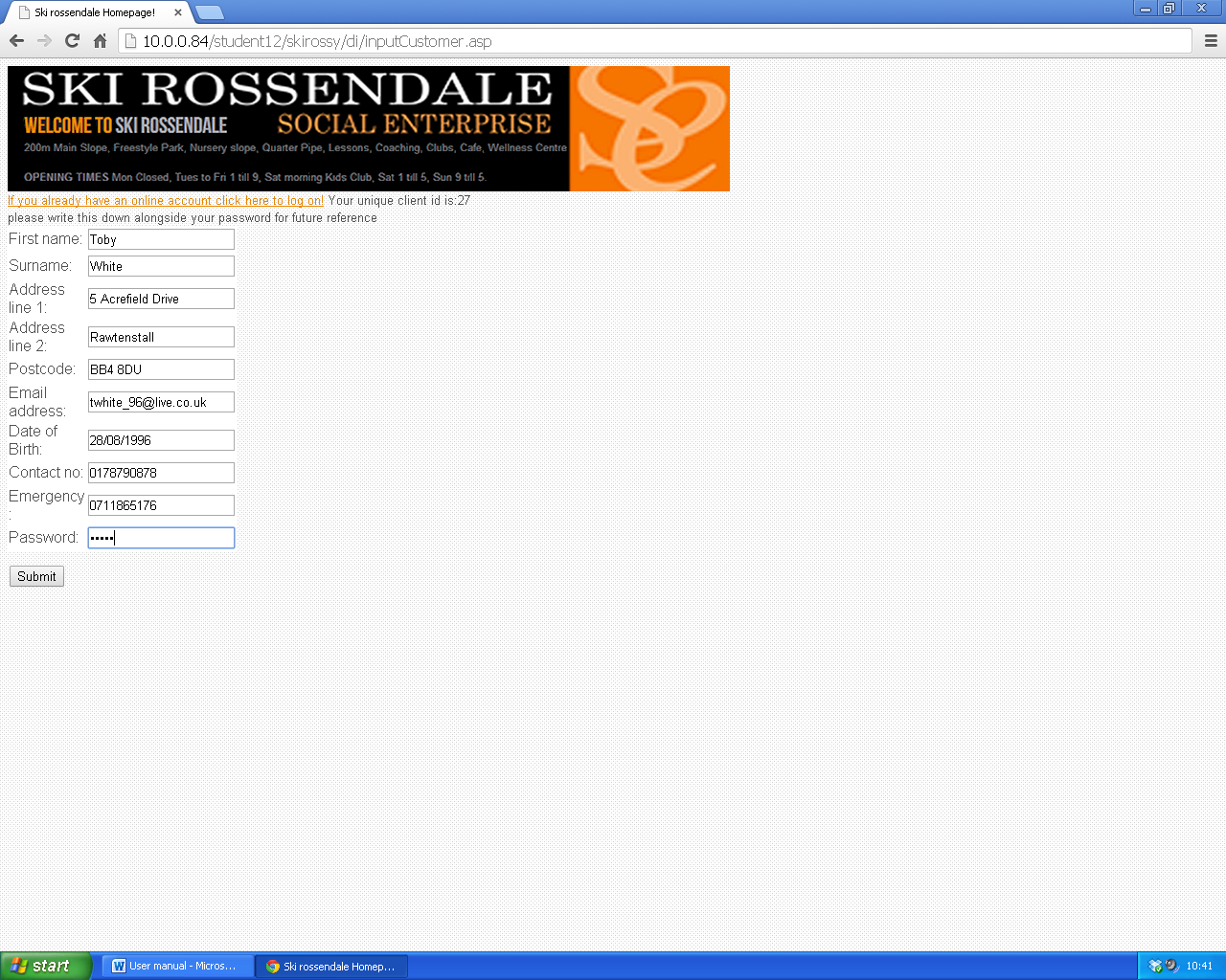

All data on this page is automatically validated within the code, so everything will be put in correct values. However if the user does enter an incorrect value, they will be given an on screen prompt with an indication to fix the problem, as shown in the below example:

Logonreal.asp- this is the page the user is prompted to on visit to the site via the include file. The user can either log on or be prompted to the registration page. On this page the user inputs their client id and password they have created. 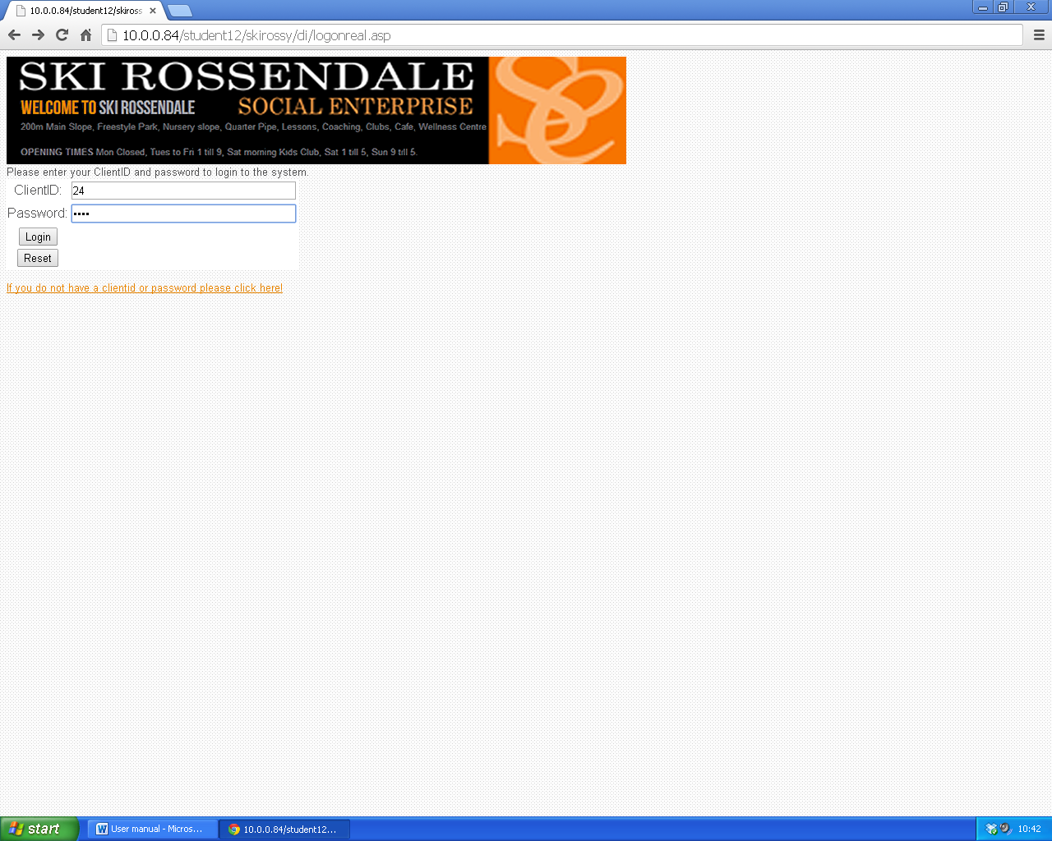

As long as the client enters the correct details they will not face problems at this stage, if they do face problems, the error message will be as follows:

Once the user does log on, they will be presented with this screen, which gives them links to the possible things they may want to do.

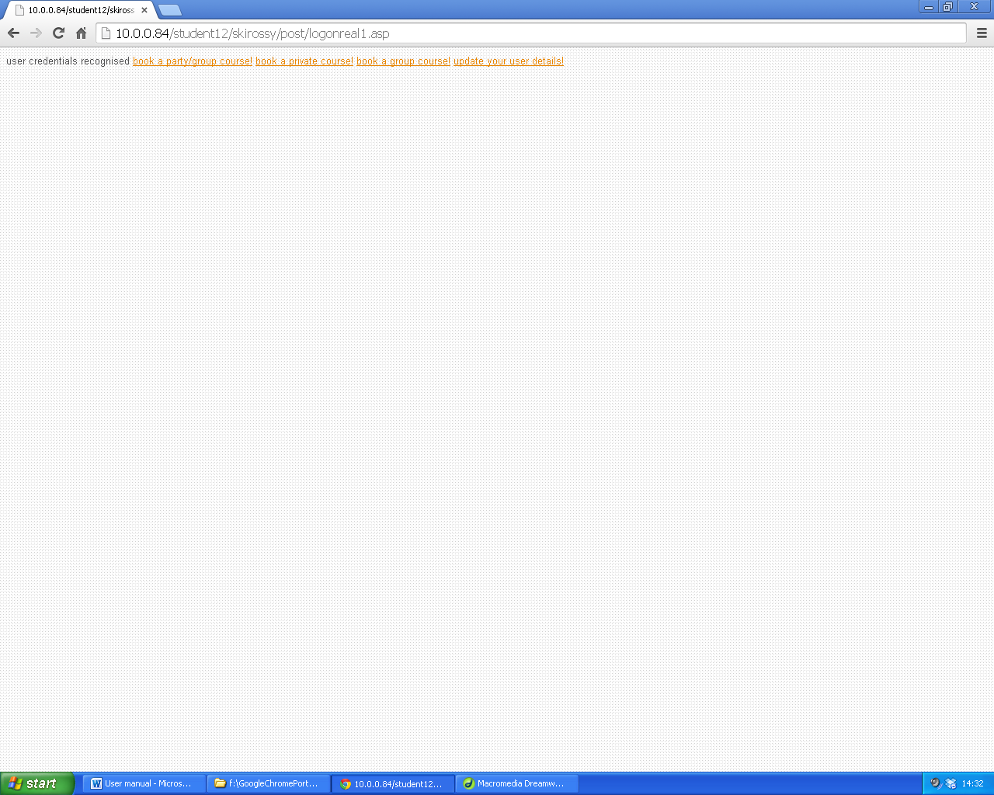

Following log on the user can then choose to either go straight to book a course, or on other occasions after logging on, the user can update their details.

Updatedetails.asp- this is the page where the user can Re input their details if any have changed, the user inputs the required information then presses submit and it is written to the database. As before, this page is almost indentical to the one above. 

Bookparty.asp- for the client to book onto a party course. The user inputs the required course attributes then presses submit and it is written to the database.

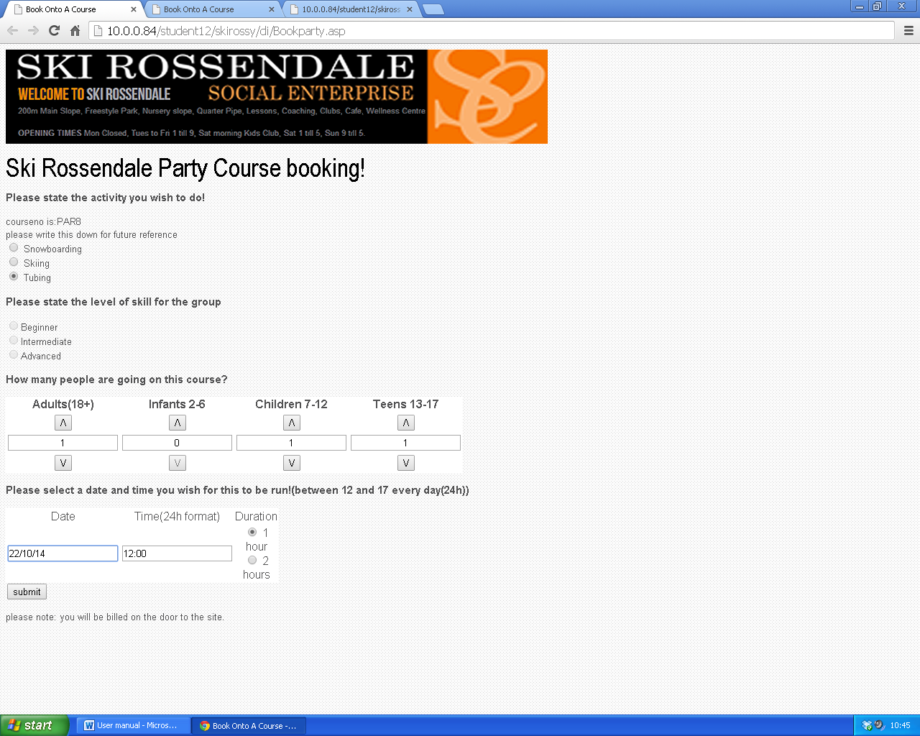

This page is also externally validated, so if the user does anything incorrectly it will be fixed with the prompt in the error message (below). Also, when the user chooses tubing, the skill level is greyed out, due to the lack of skill level in tubing, also, the user cannot go below 0 on the amount of people attending. If something is incorrectly entered, the validation will cover it as the user is not trained in the usage of the site.

Bookpriv.asp- for the client to book private lessons. The user inputs the required course attributes then presses submit and it is written to the database.

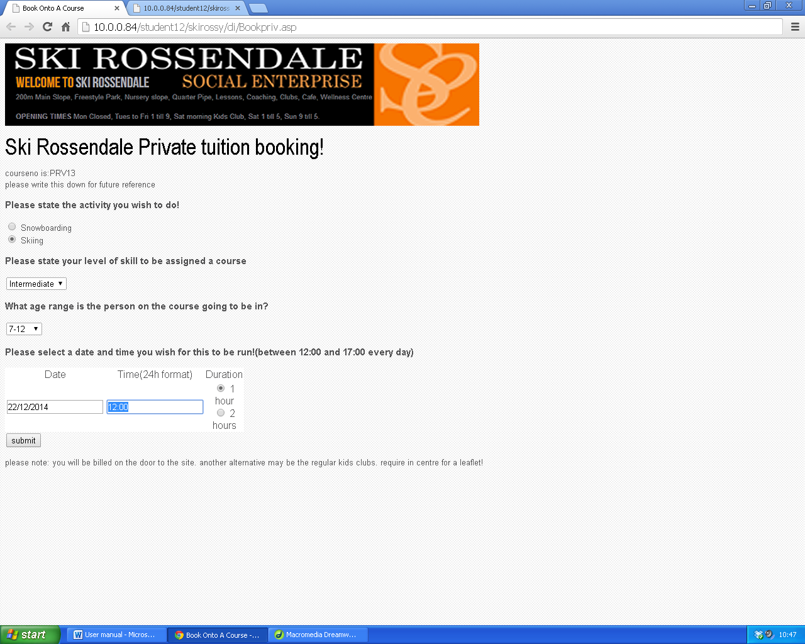

This page is also externally validated, so if the user does anything incorrectly it will be fixed with the prompt in the error message (below). All of the above combo boxes are populated via results from the database, as they have been pre-programmed. Furthermore as with throughout the user side of the code, the dates are fully validated as well as times to ensure only correct and future dates and times are allowed. If something is incorrectly entered, the validation will cover it as the user is not trained in the usage of the site.

Bookgroup.asp- where the user chooses the search criteria of the group course they are looking for- used for kids club etc. which they then use to follow onto the below page to choose a course.



This page simply shows all different activities presented in the database for the user to choose, it does not include results from a passed date.

Showgroup.asp- the user is presented this page following their entry of search criteria on the previous page- this page is directly linked to the database and will not show courses that are full or on passed dates. The user inputs the required course id of their chosen course then presses submit and they are written to the database.

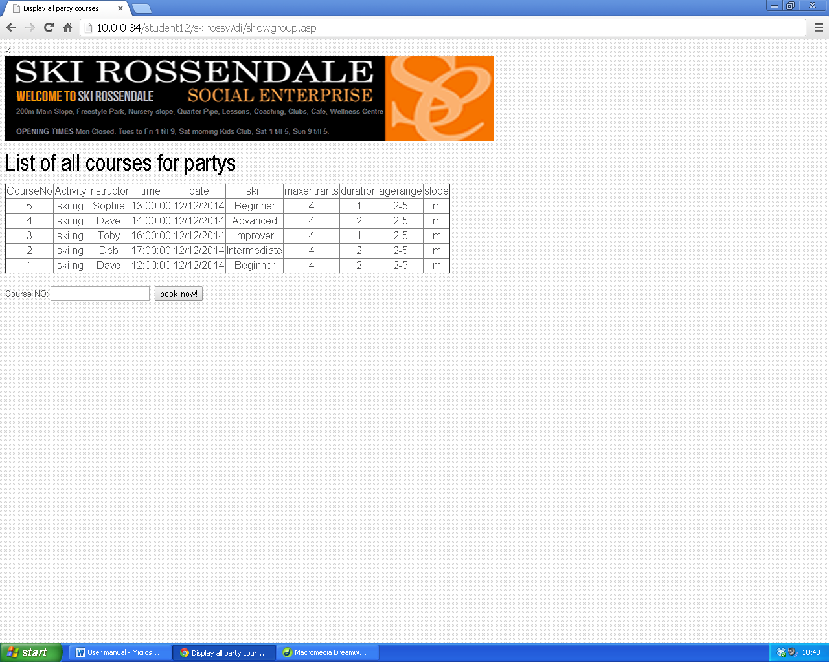

All the user is required to do is input the number of the course that they want to d and they will be booked onto it.

### Admin usage screens

The admin data entry screens are all relatively similar- these are designed with the sole purpose of completing the task at hand as quickly as possible, and the menu hierarchy has been designed for ease of use on admin behalf.

The admin screens do however require a large amount of knowledge for input, due to the amount of knowledge required when inputting data, the decision was made not to validate pages admin staff are inputting data on as they are in a position of trust to only input valid date, and therefore cannot be constrained

All drop down boxes in the query pages are populated by values from the database itself, so you should not experience issues following the positive results in the testing phase.

So as a basic set of rules:

**DATES- Must be in the format DD/MM/YYYY**

**TIMES- must be separated by a colon e.g. 12:00**

**Admin passwords- for the safety of the system you are being placed in charge of, you are in a trusting and responsible position for your password. Please ensure it is secure.**

**When inputting data please be sure to double check things such as course and client id’s before inputting them , particularly on the removal forms.**

**When using query pages, please ensure to only use one query at a time, ensuring you click the relevant submit box next to the correct query and not a different one.**

**DATE QUERIES- it is important to ensure that you choose on the date queries two dates having the first date as before the second date, otherwise no results will be returned.**

**ADMIN REMOVAL TOOLS- ensure you are putting the correct user and course ids in before you press submitted...**

**AdminLogonreal.asp- this is the page the admin staff is prompted to on visit to the site admin area via the include file. The admin must then log on to be prompted to the admin quick links page. On this page the admin inputs their id and password they have created.**

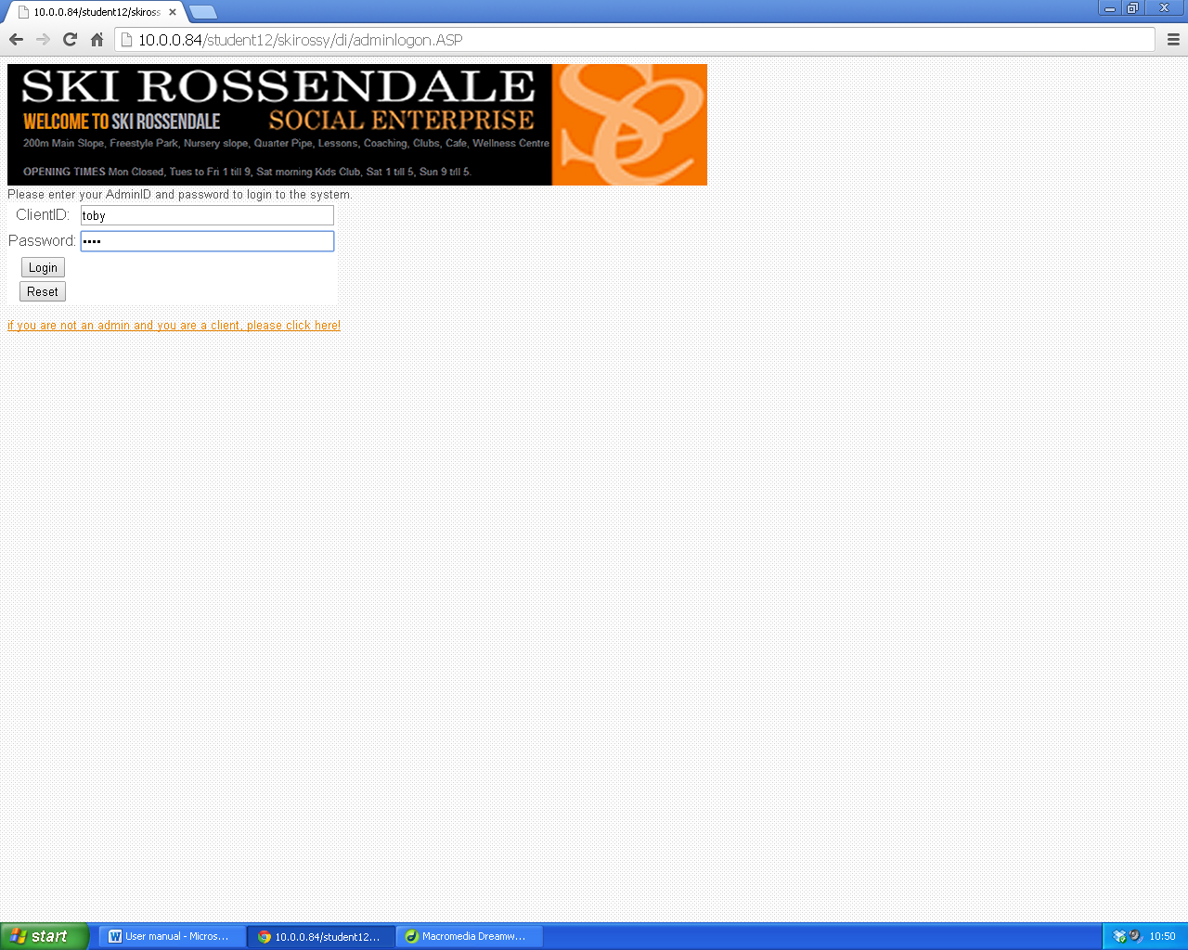

Following log on the admin will then be presented with 2 options- queries and admin tools.

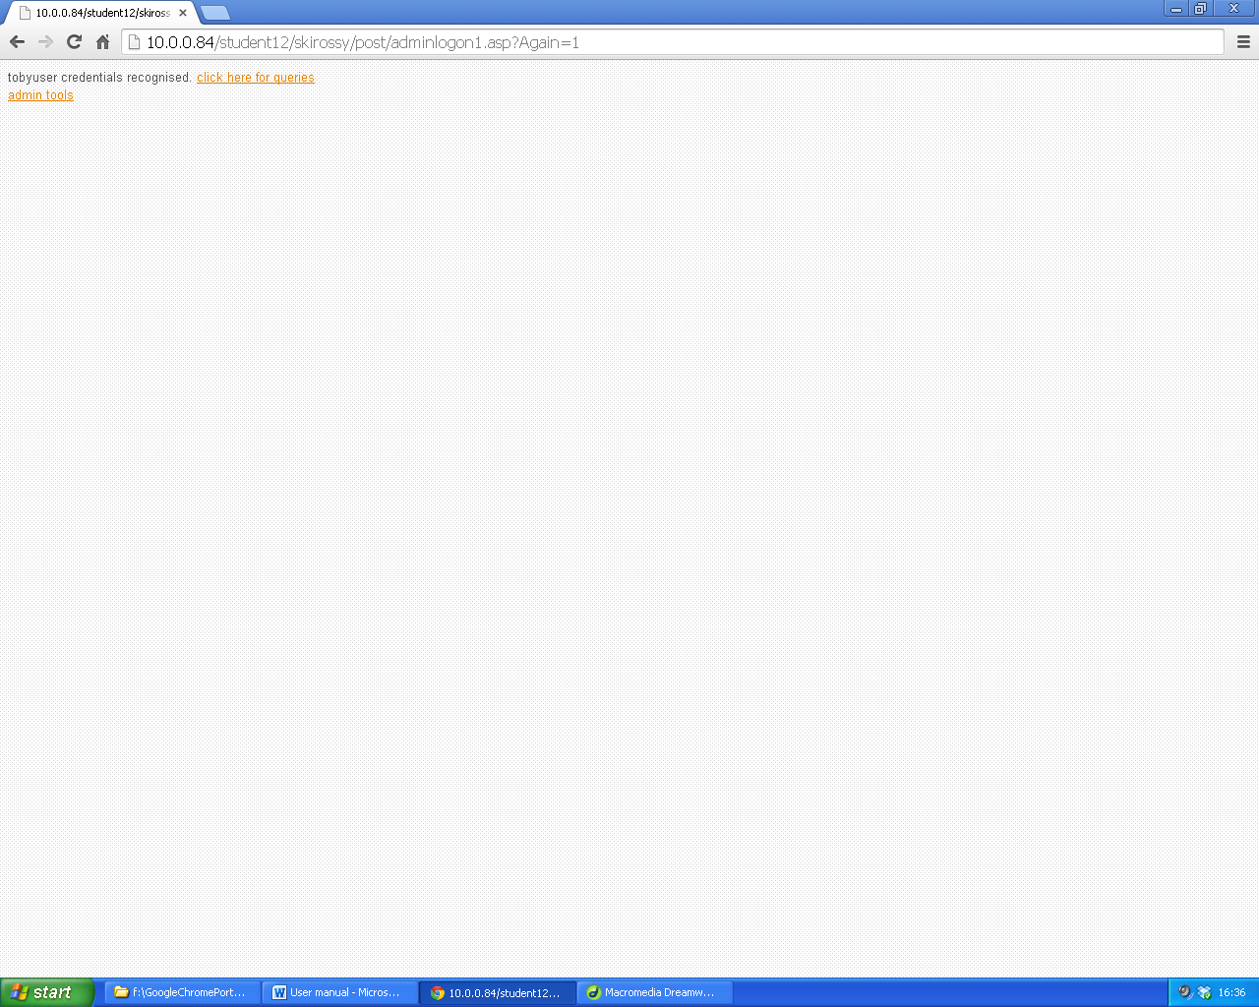

#### Search pages-

Search query pages are all clearly shown and explained on screen so the admin can clearly click on the correct link to do the task they want to do.

Searchcustomerdetails.asp- the admin will input a user’s unique client id and press submit, on the following page they will be shown the specified users details if the user exists.

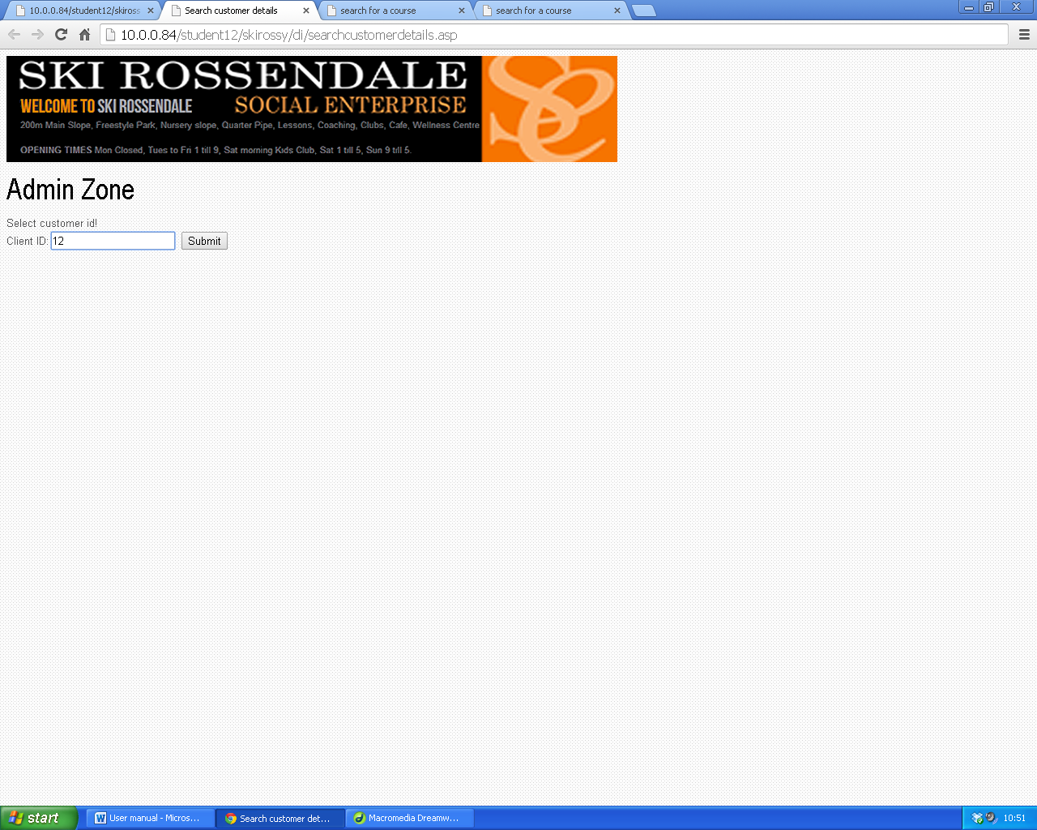

Searchparty.asp- this is the main query page for parties with a list of queries the user can use to search for courses to be run. They can search by activity, client id to see which courses a customer is booked on to, or search all courses occurring between two dates, this will suitably fulfil the user’s needs and will allow them to print out the results on each pages to show courses for the week ahead etc., following the submit button of the query selected being pressed, results will appear.

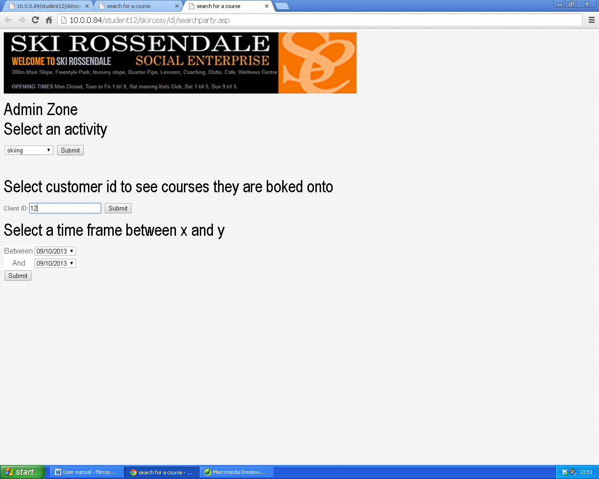

Searchprivatecourse.asp- this is the main query page for private tuition with a list of queries the user can use to search for courses to be run. They can search by instructor running the course, activity, client id to see which courses a customer is booked on to, or search all courses occurring between two dates, this will suitably fulfil the user’s needs and will allow them to print out the results on each pages to show courses for the week ahead etc., following the submit button of the query selected being pressed, results will appear.

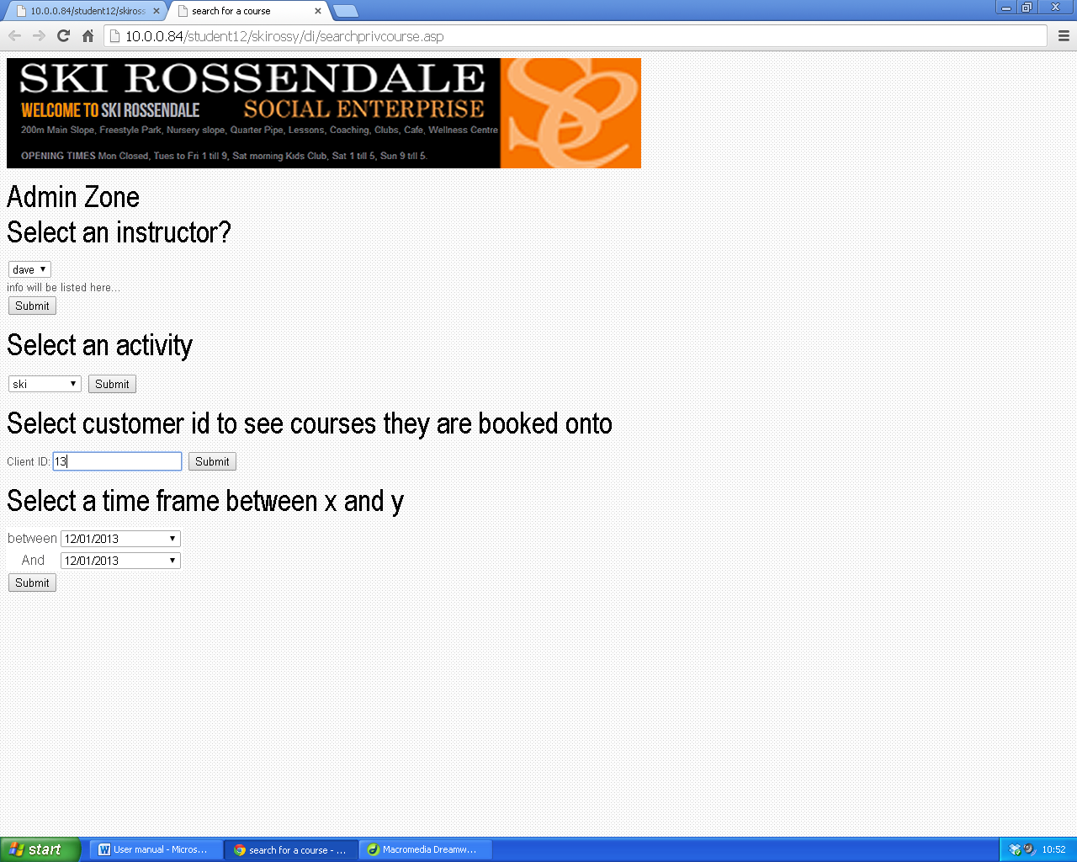

#### Admin tools-

##### Admin tools pages are all clearly shown and explained on screen so the admin can clearly click on the correct link to do the task they want to do.

##### Removal tools

Removecust1.asp- to remove a customer’s details from the database, simply input their id and they will be removed when you click submit.

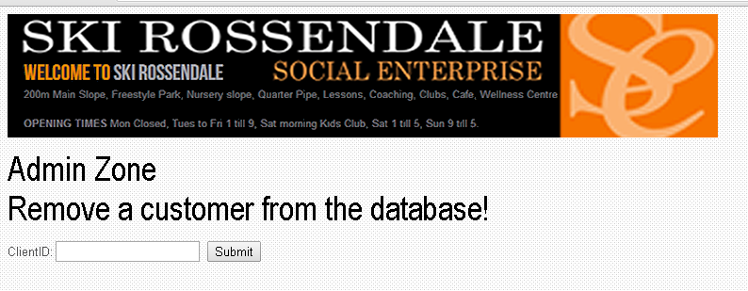

Removecustgrpmem1.asp- to remove a customer having booked onto a group course, this removes them from the database assigned to the list of customers on a group course, simply input their id and the course id and they will be removed when you click submit.



Removegrpcourse1.asp- - to remove a group course from the database, simply input the id and it will be removed when you click submit. PLEASE NOTE: YOU MUST NOTIFY BOOKED ON MEMBERS WHEN YOU DO THIS VIA EMAIL/PHONE.



Removepartycust1.asp- - to remove a customer booking of a party course from the database, simply input the course id and they will be removed when you click submit.

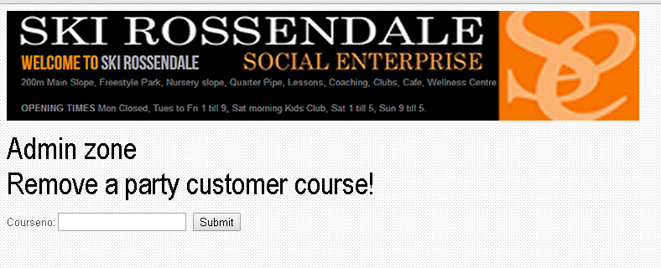

Removeprivcourse1.asp-to remove a customer’s private course booking from the database, simply input the course id and they will be removed when you click submit.



##### General upkeep tools

Updatesinstructors.asp- if the instructors available/activities on certain days changes, be sure to update it via this page simply enter the data in the required fields, the data will be stored when you click submit.

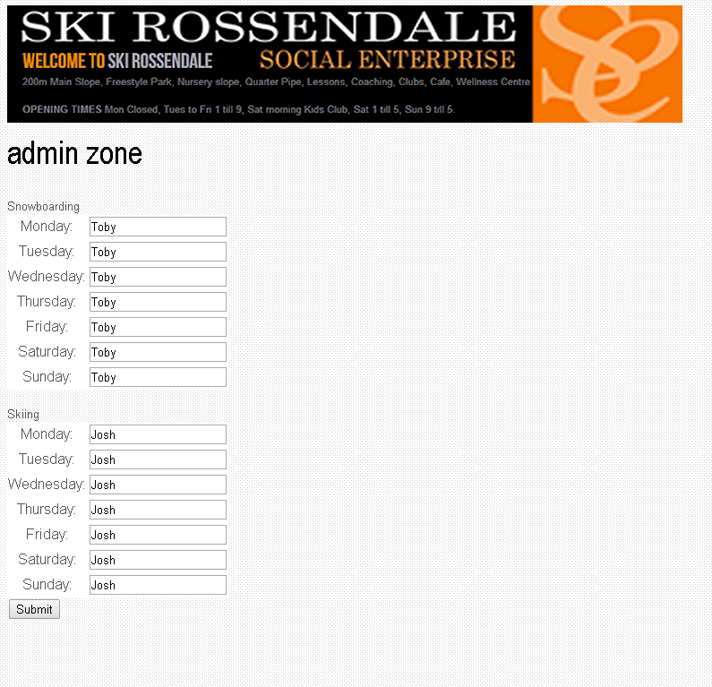

UPDATING INSTRUCTORS PROCEDURE

1. Make a fresh list of each instructor present on the given day
2. Log on as an admin and follow the steps (admin tools->update instructors for the week ahead)
3. Type all instructors into the form in the relevant boxes,
4. Double check that all names are in the correct places
5. Have a supervisor check it
6. Press submit.

NOTE: this is crucial to be correct, as this is what the code uses once a booking is made to assign an instructor to the course, so as soon as any changed are made, be sure to follow the above procedure, also ensure regular updates occur for the instructors.

Addgroupcourse.asp- if a new group course planned is sure to update it and add it to the database so users can book onto it! Simply enter the data in the required fields, the data will be stored when you click submit.

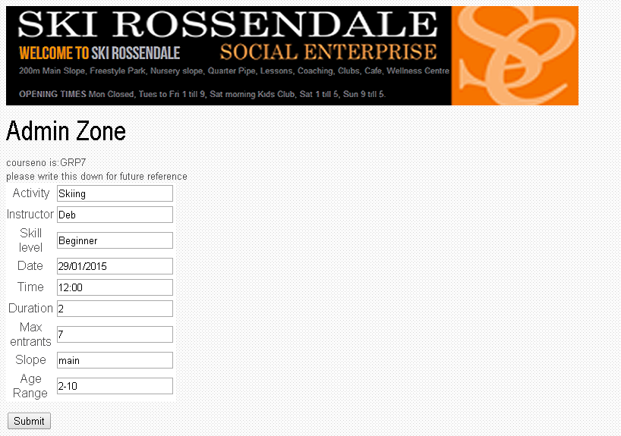

Form completion guidance-

ACTIVITY-must be an actual activity e.g. skiing/snowboarding

INSTRUCTOR- enters the instructor who intends to run the course.

SKILL LEVEL-enter the skill level required to be on the course (beginner/intermediate/improver/advanced/expert)

DATE- MUST BE IN DD/MM/YYYY FORMAT

TIME- must be separated between colons

DURATION-enter the numerical value of the duration, in hours, e.g. “2”

MAX ENTRANTS- enter the maximum amount of entrants on the course (used in code to prevent overbooking)

SLOPE-enter the slope the course will be taking place on

AGE RANGE- enter the age range of entrants to the course

Addnewadmin.asp- if a new admin joins the team is sure to enter their log on details onto the database so they are able to log on, and remember to hand them a version of this manual.

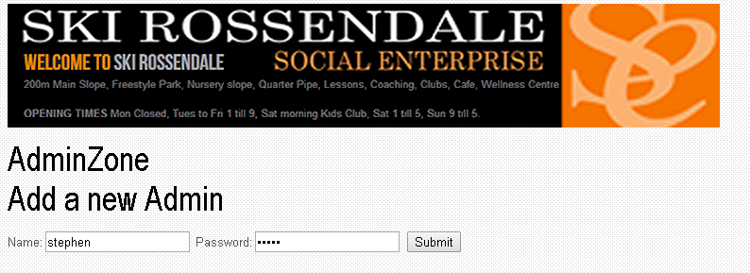

When adding a new admin ensure they input their own password and that it is secure , furthermore, when adding them as a new admin, explain the responsibilities, and give them a copy of this manual before they begin use.

## Samples of error messages and error recovery procedures

i will now show some of the possible error s a user will face, and how they will be fixed.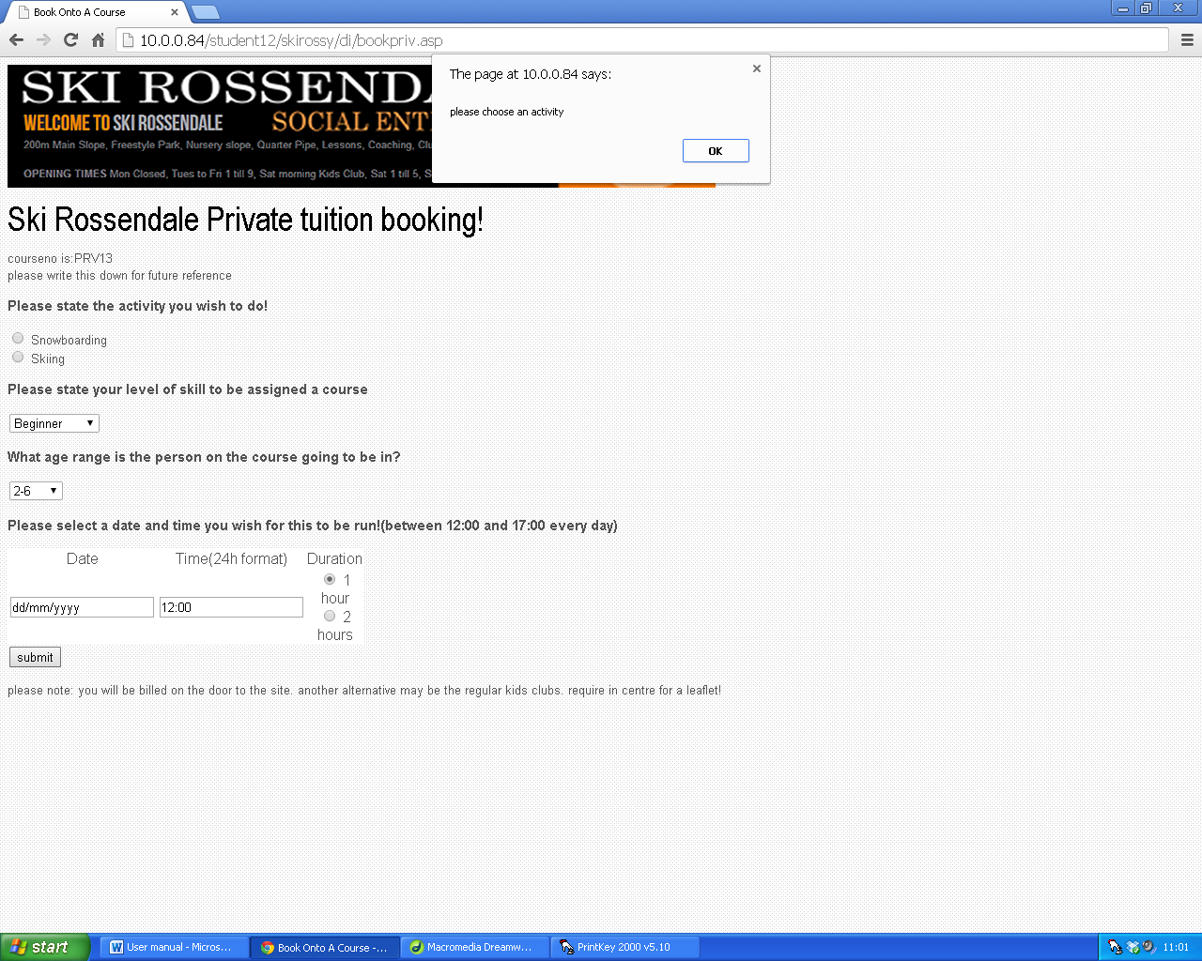

When a user does not complete required data, or meet the validation standards, an error message will be shown and the user cannot continue until it is corrected

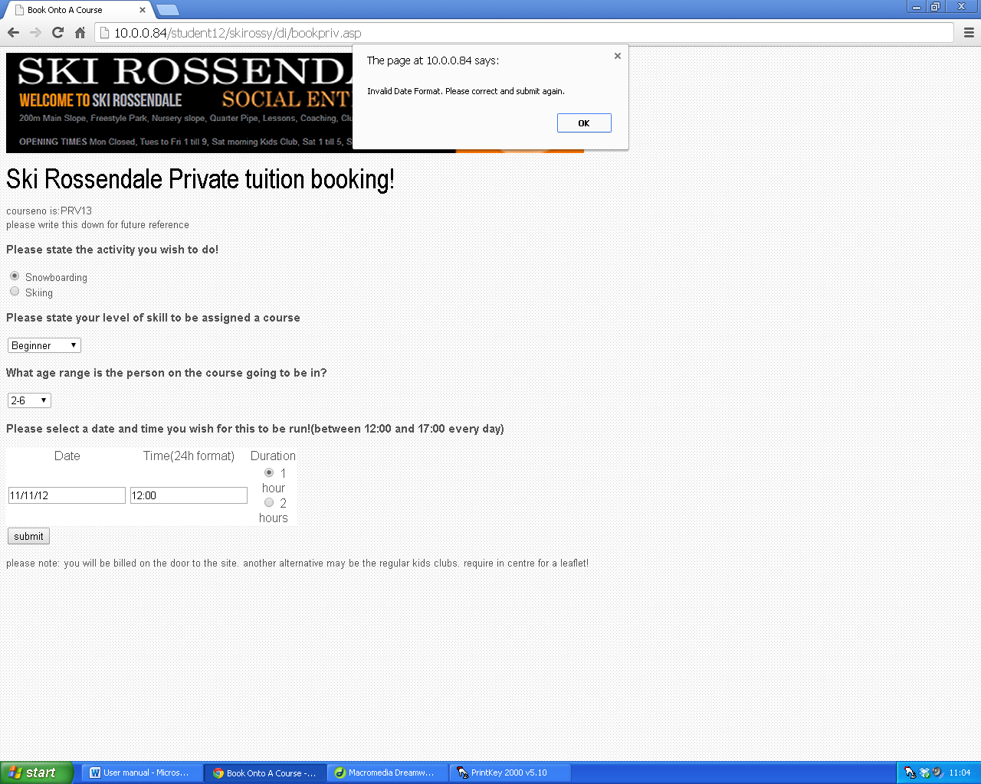

As you can see there is only one way dates can be input, as dd/mm/yyyy, if this is not met, then the date will not be accepted and an error message will show.

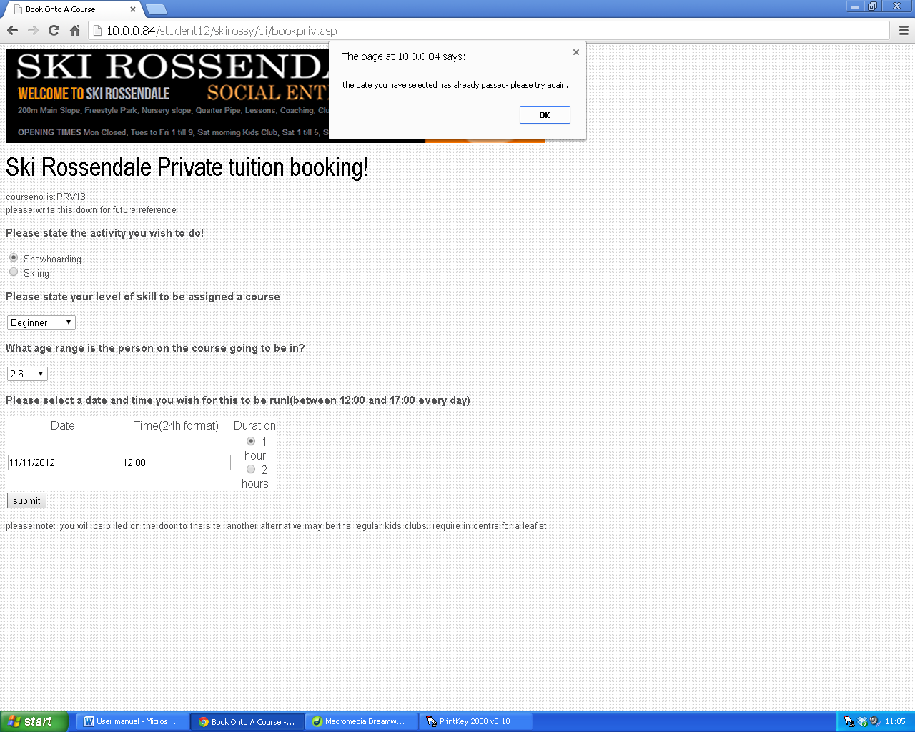

If the date has already passed, then the validation will notice this and not allow it, again an error message will show up.

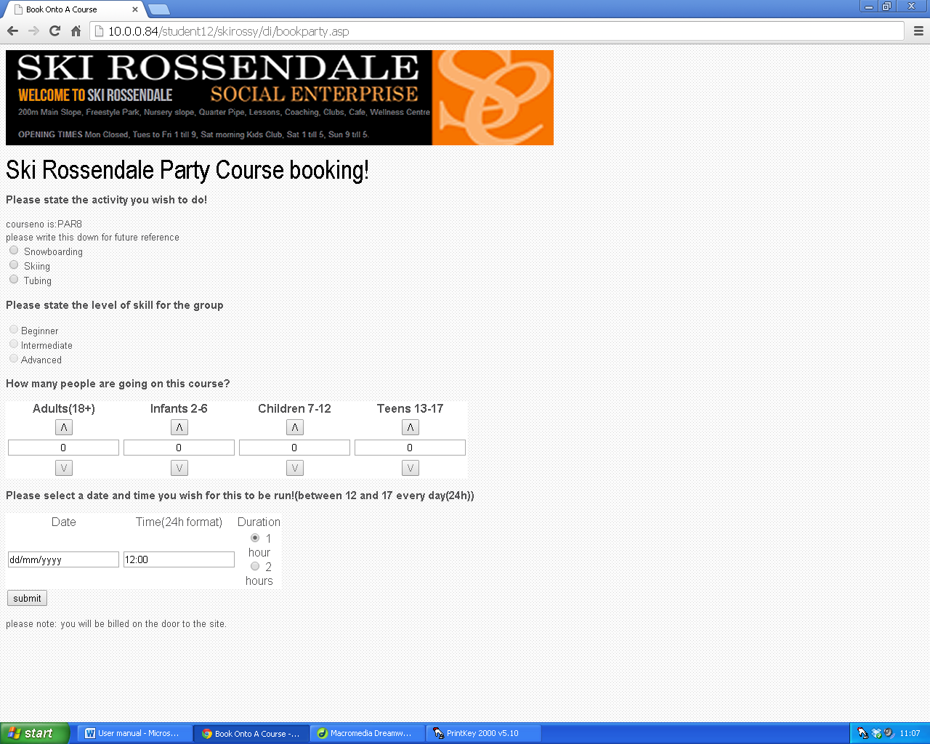

As you can see on the form attribute where a user selects the amount of people on a party course, validation, prevents the user from being able to select a negative amount of people. As you can see the down arrow is enabled if there is a number above 0.

